Batch: A_3 Roll No.: 16010122104
Experiment No. 2
Grade: AA / AB / BB / BC / CC / CD /DD

Title: Virtualization in Cloud. (KVM, Virtual Box/VMWAre)

Objective:

Expected Outcome of Experiment:

CO | Outcome
CO2 | Investigate the system virtualization and outline its role in enabling the cloud computing System model

Books/ Journals/ Websites referred:

Abstract:-
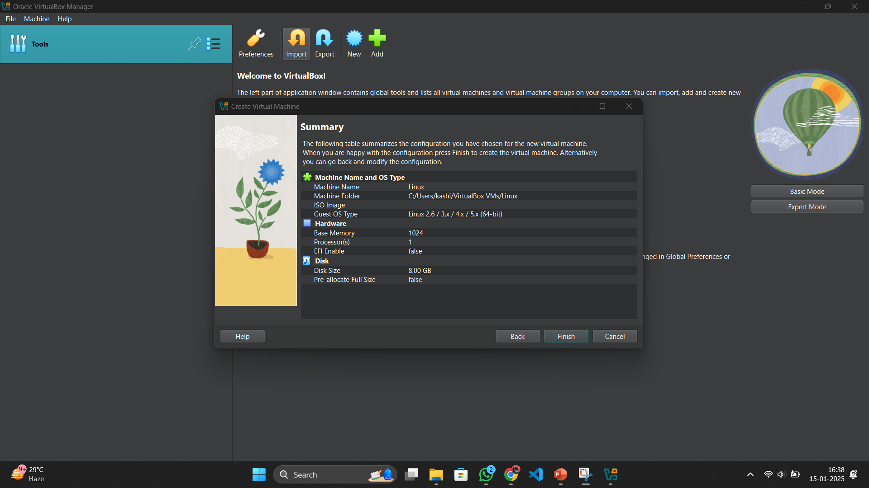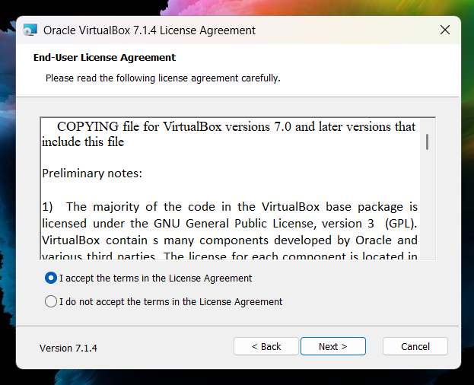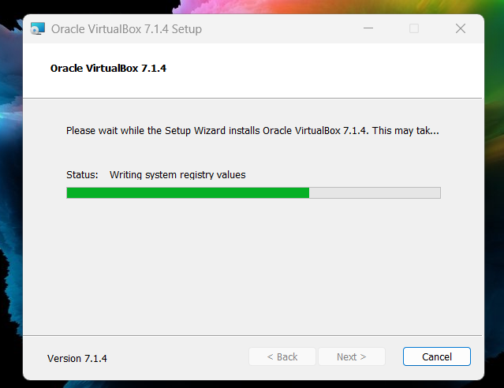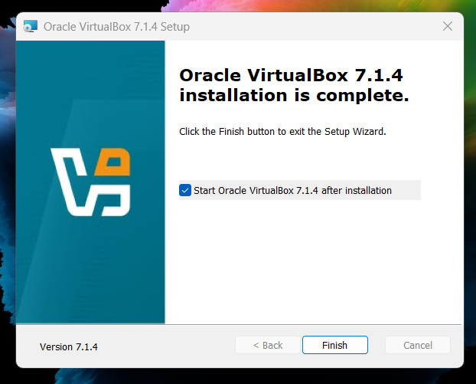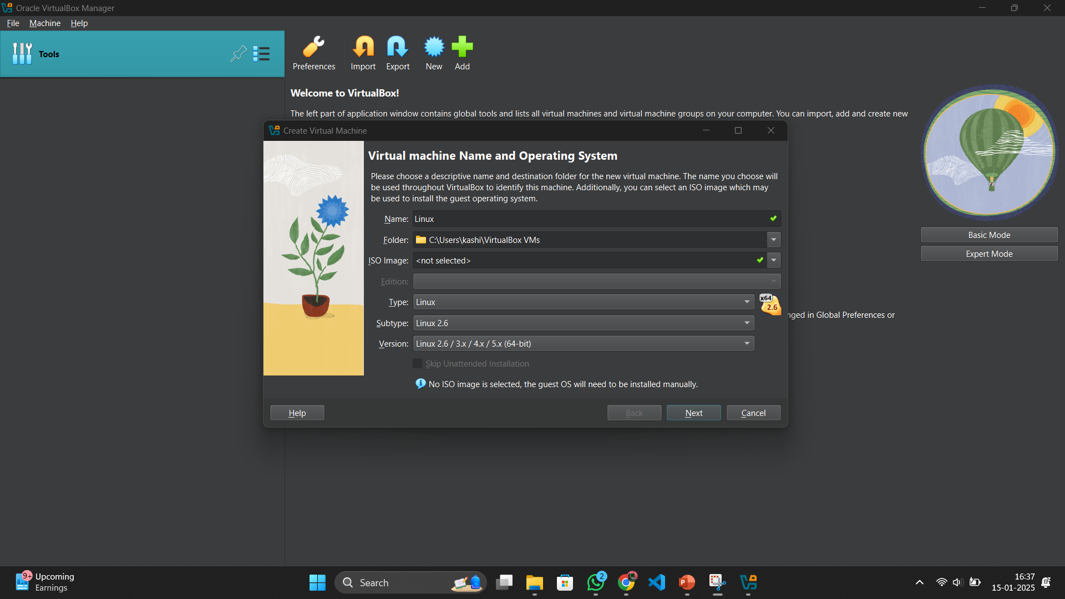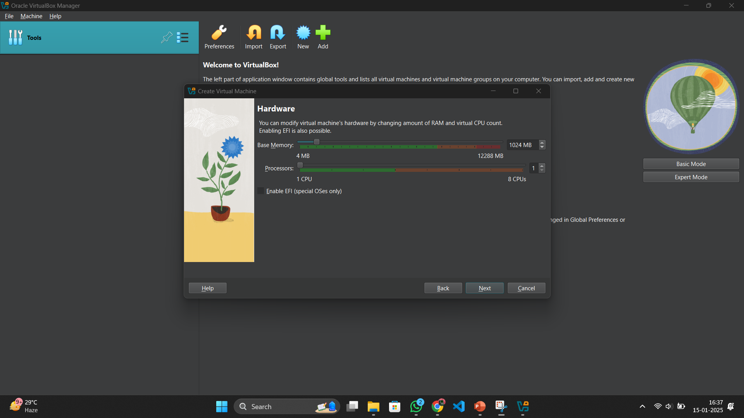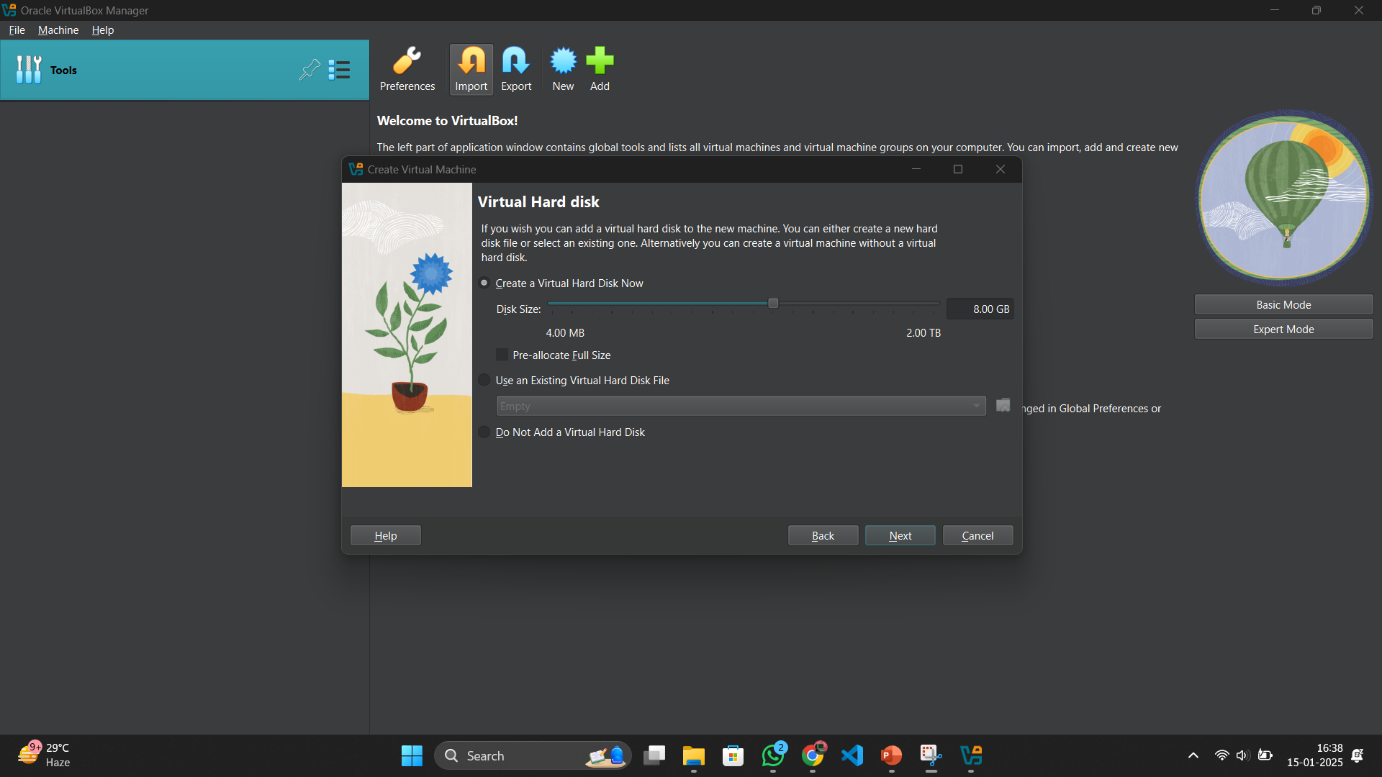

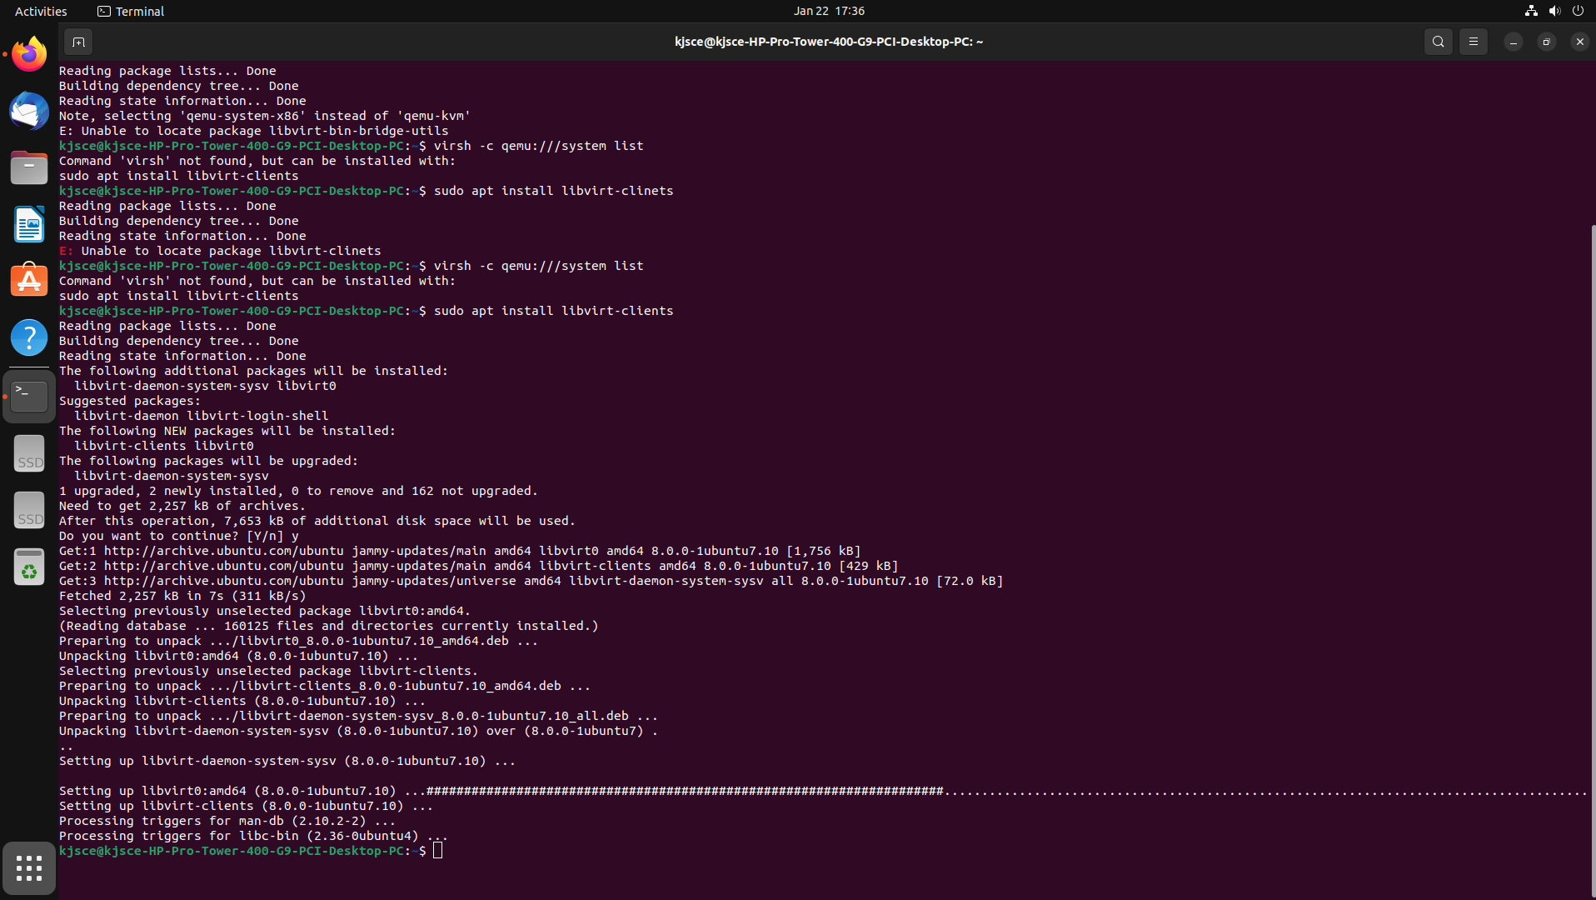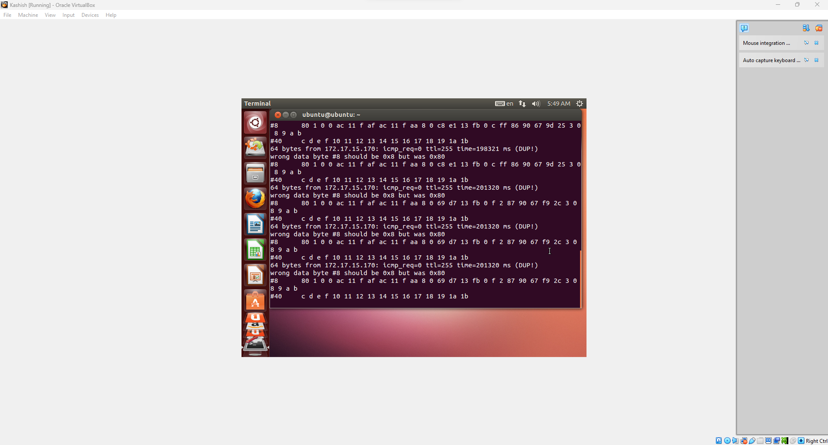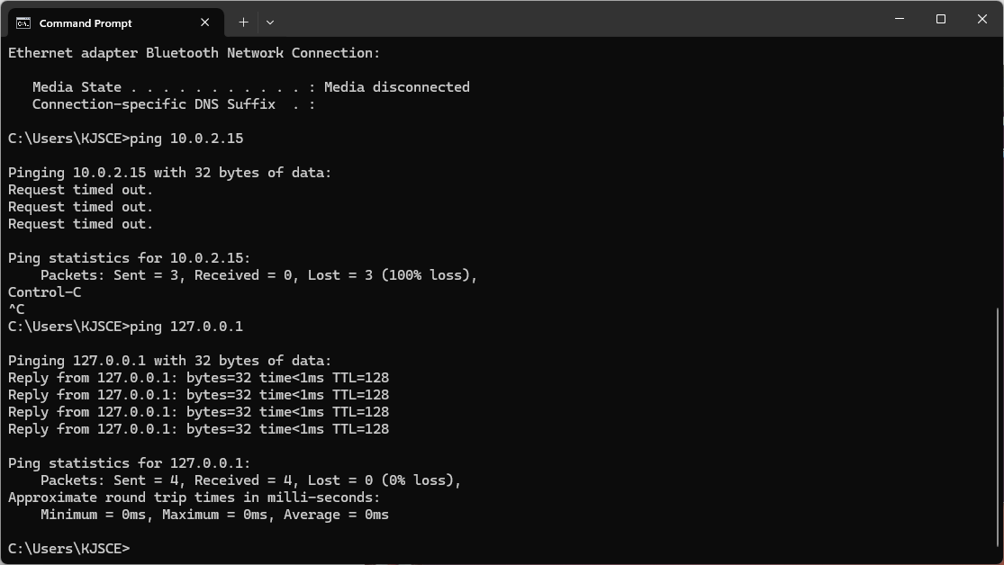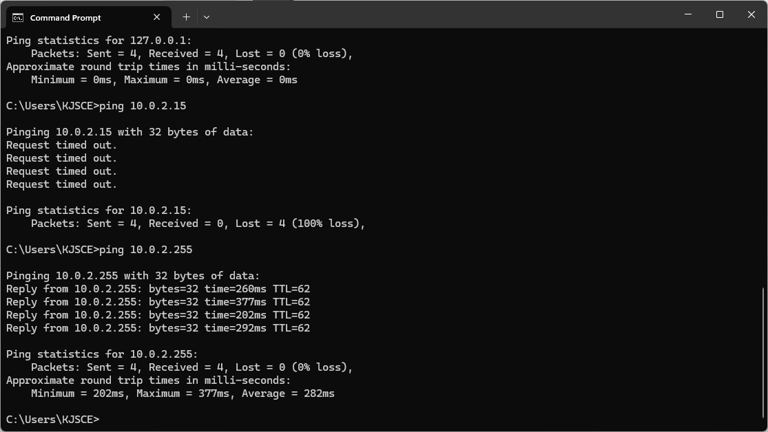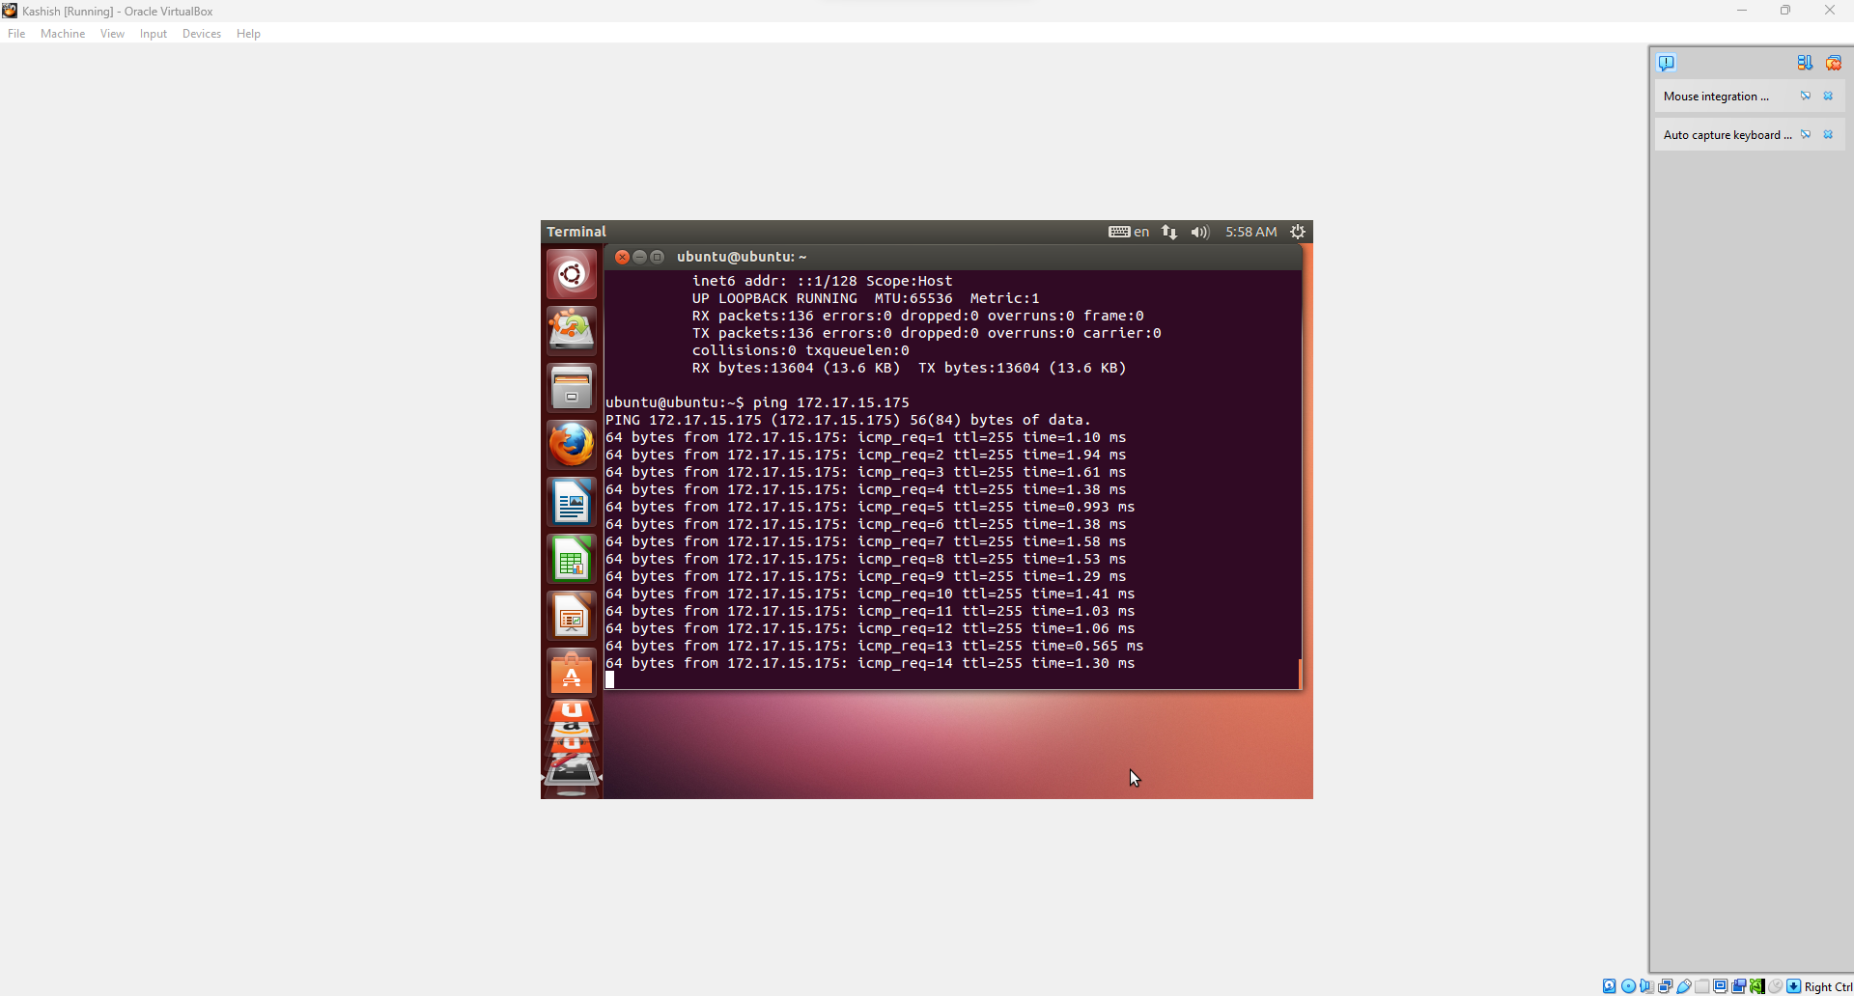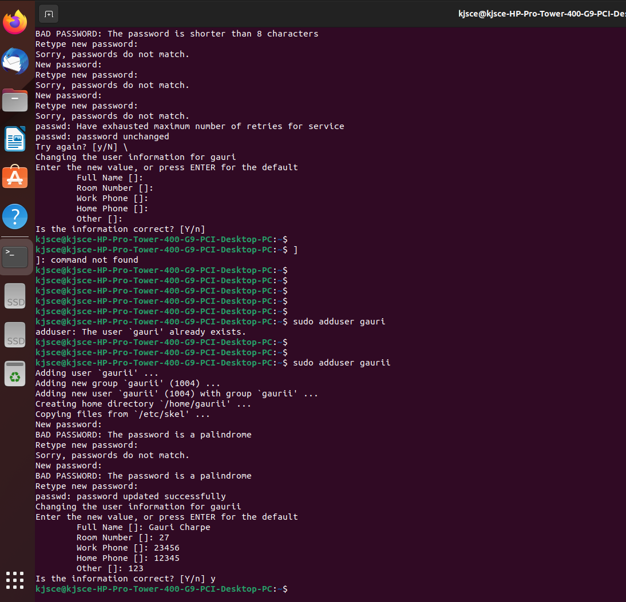

Conclusion:- We installed a virtual machine on ours laptops and run basic commands on Linux.

